🚀 Azure Data Factory – Interview Series
❓How do you control the flow of activities in an ADF Pipeline?
This is a very common Azure Data Factory interview question.
A pipeline is not always:
Activity 1 → Activity 2 → Activity 3
In real projects, we need to control when the next activity should execute based on the result of the previous activity.
That's where Activity Dependencies come in. 👇
━━━━━━━━━━━━━━━━━━━
🔹 1. Activity Dependencies
ADF allows you to define what should happen after an activity finishes.
You can configure dependencies based on:
🟢 Succeeded → Run the next activity only if the previous activity succeeds.
🔴 Failed → Run another activity when the previous activity fails.
🔵 Completed → Run after the previous activity finishes, regardless of success or failure.
🟡 Skipped → Run when the previous activity is skipped.
━━━━━━━━━━━━━━━━━━━
💼 Real-World Example
Imagine this production pipeline:
📂 Copy Sales Data
⬇️ Success
🔄 Transform Data
⬇️ Success
🗄️ Load Target Table
⬇️ Success
📧 Send Success Notification
But if Copy Activity fails:
📂 Copy Activity
⬇️ ❌ Failed
📧 Send Failure Alert
This is how we control the pipeline's execution path.
━━━━━━━━━━━━━━━━━━━
🔹 2. Conditional Activities
ADF also provides activities for more complex decisions:
🔀 If Condition → True / False decision
🔢 Switch → Multiple execution paths
🔁 ForEach → Process multiple items
⏳ Until → Repeat until a condition is met
━━━━━━━━━━━━━━━━━━━
🔹 3. Parallel Execution
Activities without dependencies can execute in parallel.
Example:
┌── Sales Copy ──┐
Start ───────┼── Customer Copy ┼──── Continue
└── Product Copy ─┘
This can reduce pipeline execution time when the activities are independent.
━━━━━━━━━━━━━━━━━━━
🎯 Production Example
A metadata-driven ingestion pipeline might look like:
Get Metadata
⬇️
Filter Files
⬇️
ForEach
⬇️
Copy Activity
⬇️
🟢 Success → Stored Procedure
🔴 Failure → Log Error + Alert
This gives you controlled, reliable orchestration instead of one straight-line workflow.
━━━━━━━━━━━━━━━━━━━
⚠️ Common Interview Mistake
Don't answer only:
"We use dependencies."
━━━━━━━━━━━━━
🎯 One-Line Interview Answer
ADF controls activity flow using dependency conditions and control-flow activities such as If Condition, Switch, ForEach, and Until, allowing pipelines to execute different paths based on execution results and business conditions.
━━━━━━
#AzureDataFactory #ADF #Azure #AzureDataEngineer #DataEngineering #DataPipeline #PipelineOrchestration #ActivityDependencies #IfCondition #SwitchActivity #ForEachActivity #UntilActivity #ETL #ELT #AzureDataLake #AzureSynapse #Databricks #MicrosoftFabric #SQLServer #CloudComputing #DataIntegration #DataOps #PipelineDesign #InterviewPreparation #InterviewTips #DP203 #LearnAzure #AzureTraining #CloudEngineering #DataEngineer #AzureInterview

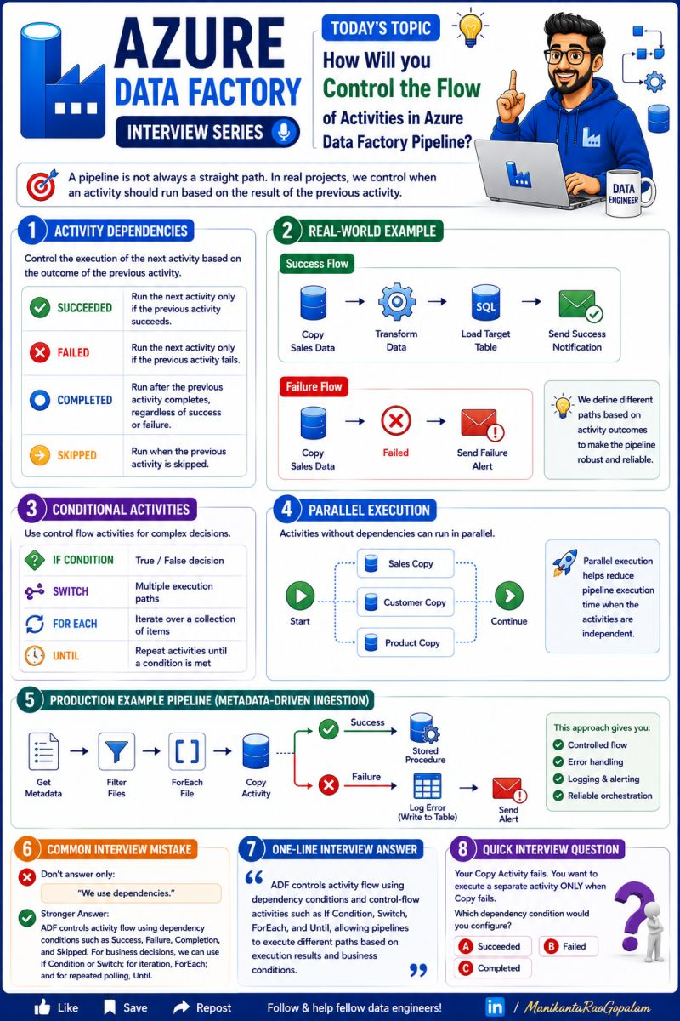

🚀 Azure Data Factory – Interview Series
❓What are Triggers in Azure Data Factory?
You built a pipeline.
But who starts it automatically?
👉 Triggers.
A Trigger tells Azure Data Factory when and how a pipeline should start running.
Think of it as:
⏰ "When this event happens → start my pipeline."
━━━━━━━━━━━━━━━━━━━
🔹 3 Important Trigger Types
1️⃣ Schedule Trigger ⏰
Runs a pipeline at a specific time or frequency.
📌 Example:
Run the Sales pipeline every day at 2:00 AM.
Schedule → Pipeline → Execute
Best for:
✅ Daily loads
✅ Weekly reports
✅ Monthly processing
━━━━━━━━━━━━━━━━━━━
2️⃣ Event Trigger ⚡
Starts a pipeline when an event occurs.
📌 Example:
A new CSV file arrives in Azure Blob Storage.
➡️ File arrives
➡️ Event Trigger fires
➡️ ADF pipeline starts
➡️ File is processed
Best for:
✅ File-arrival processing
✅ Real-time-ish ingestion
✅ Event-driven pipelines
━━━━━━━━━━━━━━━━━━━
3️⃣ Tumbling Window Trigger 🪟
Runs pipelines in fixed, continuous time windows.
📌 Example:
Process sales data every 1 hour:
🕐 1:00–2:00
🕑 2:00–3:00
🕒 3:00–4:00
Each window represents a specific time period.
Best for:
✅ Time-based incremental processing
✅ Backfilling historical windows
✅ Dependency-based processing
━━━━━━━━━━━━━━━━━━━
💼 Real-World Example
A retail company receives sales files throughout the day.
📂 New file arrives
⬇️
⚡ Event Trigger
⬇️
🔷 ADF Pipeline
⬇️
📦 Copy Activity
⬇️
🗄️ Azure Data Lake
⬇️
⚡ Databricks Transformation
No manual pipeline execution is required.
━━━━━━━━━━━━━━━━━━━
🎯 Easy Way to Remember
⏰ Schedule = Time
⚡ Event = Something Happens
🪟 Tumbling Window = Fixed Time Windows
━━━━━━━━━━━━━━━━━━━
❌ Common Mistakes
❌ Confusing a Trigger with a Pipeline
❌ Using Schedule Trigger when event-based processing is required
❌ Ignoring trigger dependencies
❌ Creating multiple unnecessary triggers for the same pipeline
━━━━━━━━━━━━━━━━━━━
🎯 One-Line Interview Answer
An ADF Trigger defines when a pipeline should start. The main types are Schedule, Event, and Tumbling Window triggers, each designed for different orchestration scenarios.
━━━━━━━━━━━━━━━━━━━
💡 Interview Question
A CSV file can arrive at any time, and you want the pipeline to start immediately after the file arrives.
Which trigger would you choose?
⏰ Schedule Trigger
⚡ Event Trigger
🪟 Tumbling Window Trigger
👇 Drop your answer in the comments!
If this post helped you, Like ❤️ | Save 📌 | Repost ♻️ to help fellow Data Engineers.
#AzureDataFactory #ADF #Azure #AzureDataEngineer #DataEngineering #ADFTriggers #ScheduleTrigger #EventTrigger #TumblingWindow #DataPipeline #ETL #ELT #DataIntegration #AzureDataLake #AzureSynapse #Databricks #SQLServer #MicrosoftFabric #DP203 #InterviewPreparation #InterviewTips #CloudComputing #DataOps #PipelineDesign #LearnAzure #CloudEngineering #ModernDataPlatform #DataEngineer #AzureTraining #AzureInterview

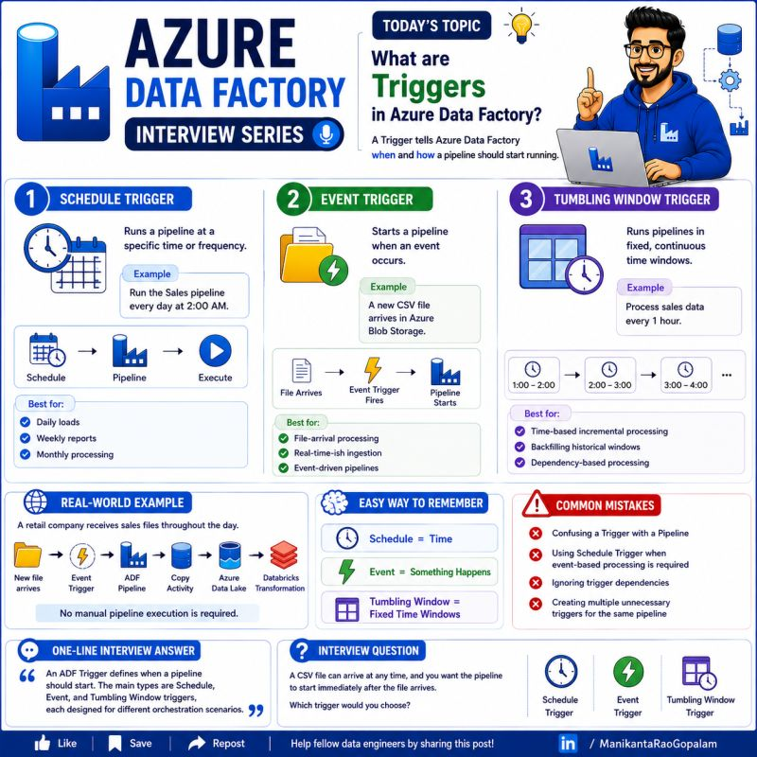

🚀 Are you still loading the entire dataset every time?
There's a smarter way: Change Data Capture (CDC).
Instead of processing millions of records repeatedly, CDC identifies only the data that has changed since the last load and processes just those records.
This approach is one of the most common techniques used in modern Data Engineering pipelines.
What does CDC capture?
✅ Inserts – New records added
✅ Updates – Existing records modified
✅ Deletes – Records removed
Why do Data Engineers use CDC?
✔ Faster ETL pipelines
✔ Reduced data movement
✔ Lower compute costs
✔ Near real-time data synchronization
✔ Improved performance and scalability
Common ways to implement CDC
🔹 Timestamp-based CDC
🔹 Transaction Log-based CDC
🔹 Trigger-based CDC
🔹 Snapshot Comparison
Real-world example
Imagine a Customers table with 10 million records.
If only 2,000 records changed today, would you reload all 10 million?
No.
With CDC, only those 2,000 changed records are processed, making your ETL pipeline significantly faster and more efficient.
This is exactly why CDC is widely used in Azure Data Factory, Azure Databricks, SQL Server, Delta Lake, Snowflake, and many enterprise data platforms.
💬 Interview Question:
Which CDC implementation have you used in your projects—Timestamp-based, Watermark, SQL Server CDC, Delta Change Data Feed (CDF), or another approach? Share your experience in the comments.
#AzureDataEngineer #Azure #AzureDataFactory #ADF #AzureDatabricks #Databricks #ApacheSpark #Spark #PySpark #SparkSQL #SQL #SQLServer #TSQL #DeltaLake #DeltaTables #ChangeDataCapture #CDC #IncrementalLoad #ETL #ELT #DataEngineering #DataEngineer #DataPipeline #DataPipelines #DataWarehouse #DataLake #DataLakehouse #MicrosoftFabric #Fabric #AzureSynapse #SynapseAnalytics #BigData #CloudComputing #CloudData #Analytics #BusinessIntelligence #DataAnalytics #DataArchitecture #DataTransformation #DataMigration #DataIntegration #DataGovernance #DataManagement #DataOps #DevOps #AzureDeveloper #MicrosoftAzure #LearningInPublic #TechCommunity #TechCareer #CareerGrowth #Upskilling #InterviewPreparation #TechInterview #SoftwareEngineer #Programming #Coding #Developers #DataScience #MachineLearning #ArtificialIntelligence #AI #GenAI #OpenToWork #LinkedInCreators #LinkedInLearning #TechTips #CloudEngineer #DataProfessionals #AnalyticsEngineering #ModernDataStack #DataPlatform #SQLTips #PySparkDeveloper #BigDataEngineering #ETLDeveloper #DataWarehouseDeveloper #CloudArchitecture #TechEducation #LearnDataEngineering #DataEngineeringCommunity

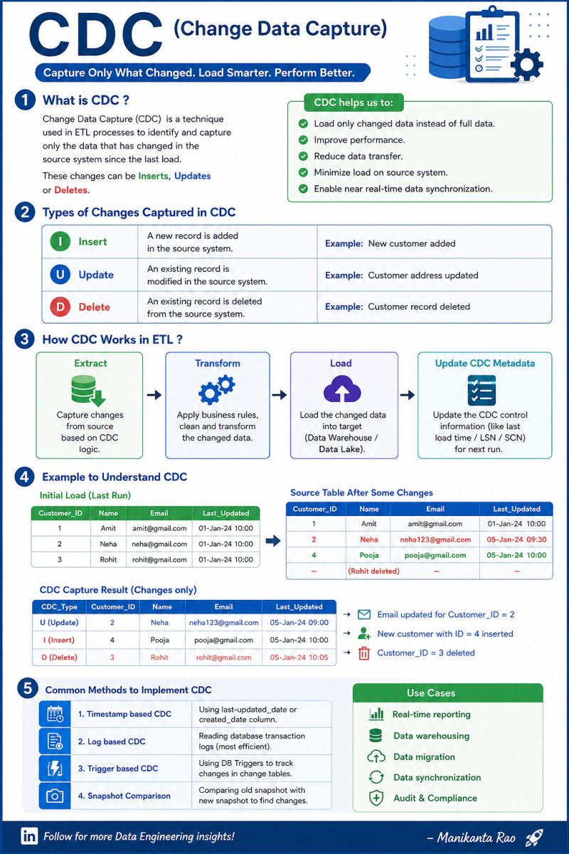

🚀 Azure Data Factory – Interview Series
❓What is the Stored Procedure Activity in Azure Data Factory, and when should you use it?
Not every transformation needs Databricks or Mapping Data Flow.
If your business logic already exists in SQL Server or Azure SQL Database, you can execute it directly using Stored Procedure Activity.
This is one of the most common activities used in enterprise ADF projects.
━━━━━━━━━━━━━━━━━━━
🔹 What is Stored Procedure Activity?
Stored Procedure Activity executes a SQL Stored Procedure from an ADF pipeline.
It allows you to run database-side logic such as:
✅ Data validation
✅ Data transformation
✅ Merge operations
✅ Logging
✅ Audit updates
Think of it as:
🗄️ "Let the database do the processing."
━━━━━━━━━━━━━━━━━━━
💼 Real-World Example
A retail company loads sales data into a staging table.
After the Copy Activity finishes:
1️⃣ Copy Activity loads data into Sales_Stage
2️⃣ Stored Procedure validates records
3️⃣ Removes duplicates
4️⃣ Merges data into the final Sales table
5️⃣ Updates the audit log
Everything happens automatically from the ADF pipeline.
━━━━━━━━━━━━━━━━━━━
🔹 Common Use Cases
✅ Execute MERGE statements
✅ Load data from staging to target
✅ Update audit tables
✅ Perform data quality checks
✅ Execute business rules inside SQL
━━━━━━━━━━━━━━━━━━━
🌟 Best Practices
✔ Keep stored procedures focused on one task
✔ Pass parameters instead of hardcoding values
✔ Handle errors using TRY...CATCH
✔ Log execution status for troubleshooting
━━━━━━━━━━━━━━━━━━━
❌ Common Mistakes
❌ Writing very large stored procedures
❌ Hardcoding table names or dates
❌ Ignoring error handling
❌ Not indexing target tables for MERGE operations
━━━━━━━━━━━━━━━━━━━
🎯 One-Line Interview Answer
Stored Procedure Activity executes a SQL stored procedure from an Azure Data Factory pipeline. It is commonly used for database-side transformations, validation, MERGE operations, and audit logging.
━━━━━━━━━━━━━━━━━━━
💡 Interview Tip
A common production workflow is:
📂 Copy Activity → Stored Procedure Activity → Lookup Activity → Success Notification
This separates data movement from business logic, making the solution easier to maintain.
━━━━━━━━━━━━━━━━━━━
💬 Question for You
How do you usually perform transformations in your projects?
🗄️ Stored Procedures
⚡ Azure Databricks
🔷 Mapping Data Flow
Share your approach in the comments! 👇
If this post helped you, don't forget to Like ❤️ | Save 📌 | Repost ♻️ to support fellow Data Engineers.
#AzureDataFactory #ADF #Azure #AzureDataEngineer #DataEngineering #StoredProcedure #SQLServer #AzureSQL #ETL #ELT #DataPipeline #AzureDataLake #AzureSynapse #Databricks #PipelineDesign #InterviewPreparation #InterviewTips #MicrosoftFabric #DP203 #CloudComputing #DataIntegration #LearnAzure #CloudEngineering #DataOps #ModernDataPlatform #DatabaseDevelopment

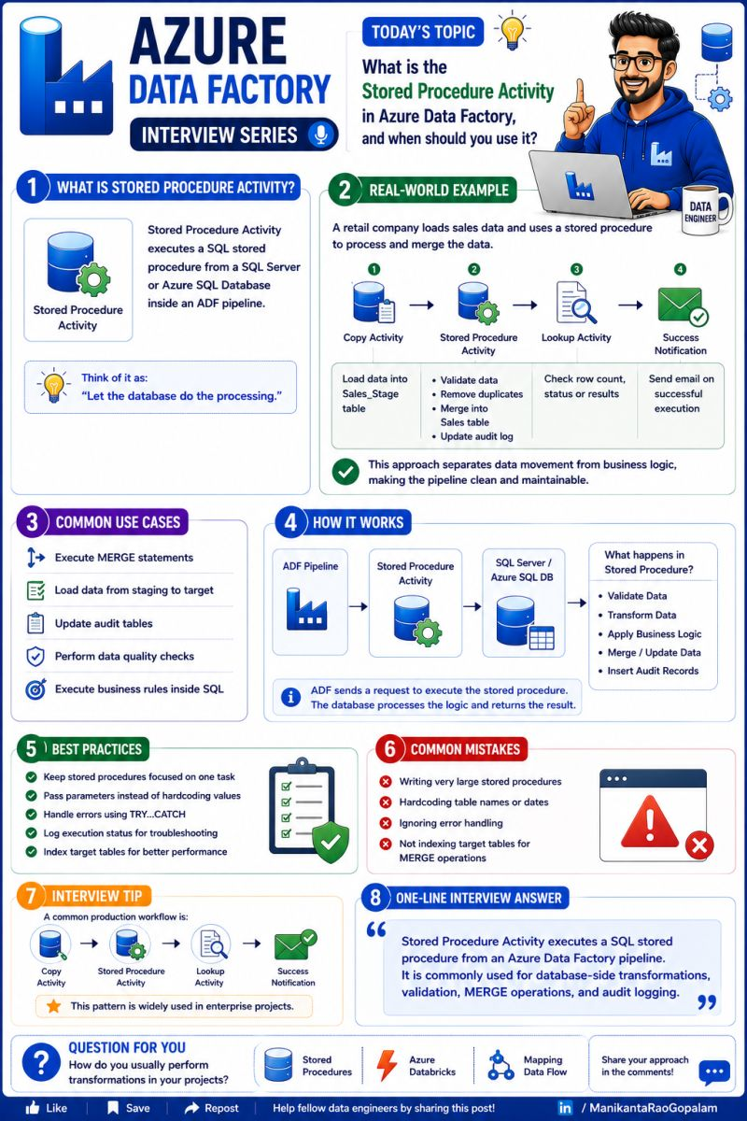

🚀 Azure Data Factory – Interview Series
❓What is the Append Variable Activity in Azure Data Factory, and when should you use it?
Imagine you're processing 100 files and want to keep track of which files were processed successfully.
Instead of overwriting the value every time, Append Variable Activity lets you add each value to a list.
It's one of the most useful activities for building dynamic and metadata-driven pipelines.
━━━━━━━━━━━━━━━━━━━
🔹 What is Append Variable Activity?
Append Variable Activity adds a new value to an Array Variable during pipeline execution.
Think of it as:
📝 "Keep adding items to a growing list."
Unlike Set Variable Activity, which replaces the existing value, Append Variable keeps the previous values and adds a new one.
━━━━━━━━━━━━━━━━━━━
💼 Real-World Example
Your ADF pipeline processes these files:
📄 Sales.csv
📄 Customers.csv
📄 Products.csv
After each successful Copy Activity:
✅ Append Sales.csv
✅ Append Customers.csv
✅ Append Products.csv
At the end of the pipeline, your array contains:
📋 Processed Files:
• Sales.csv
• Customers.csv
• Products.csv
This list can be used for logging, auditing, or sending email notifications.
━━━━━━━━━━━━━━━━━━━
🔹 Common Use Cases
✅ Track processed files
✅ Build audit logs
✅ Store successful table names
✅ Collect failed records
✅ Create dynamic email summaries
━━━━━━━━━━━━━━━━━━━
🌟 Best Practices
✔ Use Append Variable only with Array Variables
✔ Use meaningful variable names
✔ Initialize the array before appending values
✔ Use the collected values for reporting or notifications
━━━━━━━━━━━━━━━━━━━
❌ Common Mistakes
❌ Appending to a String Variable
❌ Forgetting to initialize the Array Variable
❌ Using Append Variable when Set Variable is sufficient
━━━━━━━━━━━━━━━━━━━
🎯 One-Line Interview Answer
Append Variable Activity adds a value to an Array Variable during pipeline execution. It is commonly used to collect multiple values such as processed files, table names, or error messages.
━━━━━━━━━━━━━━━━━━━
💡 Interview Tip
Know the difference:
📝 Set Variable → Replace one value
📋 Append Variable → Add multiple values to an array
This distinction is commonly asked in Azure Data Factory interviews.
━━━━━━━━━━━━━━━━━━━
💬 Question for You
Where have you used Append Variable Activity?
📂 Processed Files
📊 Table Names
❌ Error Messages
📧 Email Summary
Share your experience in the comments! 👇
If this post helped you, don't forget to Like ❤️ | Save 📌 | Repost ♻️ to support fellow Data Engineers.
#AzureDataFactory #ADF #Azure #AzureDataEngineer #DataEngineering #AppendVariable #PipelineVariables #ETL #ELT #DataPipeline #AzureDataLake #AzureSynapse #Databricks #SQLServer #InterviewPreparation #InterviewTips #MicrosoftFabric #DP203 #CloudComputing #DataIntegration #LearnAzure #CloudEngineering #DataOps #ModernDataPlatform #PipelineDesign #AzureTraining

